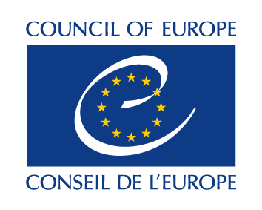
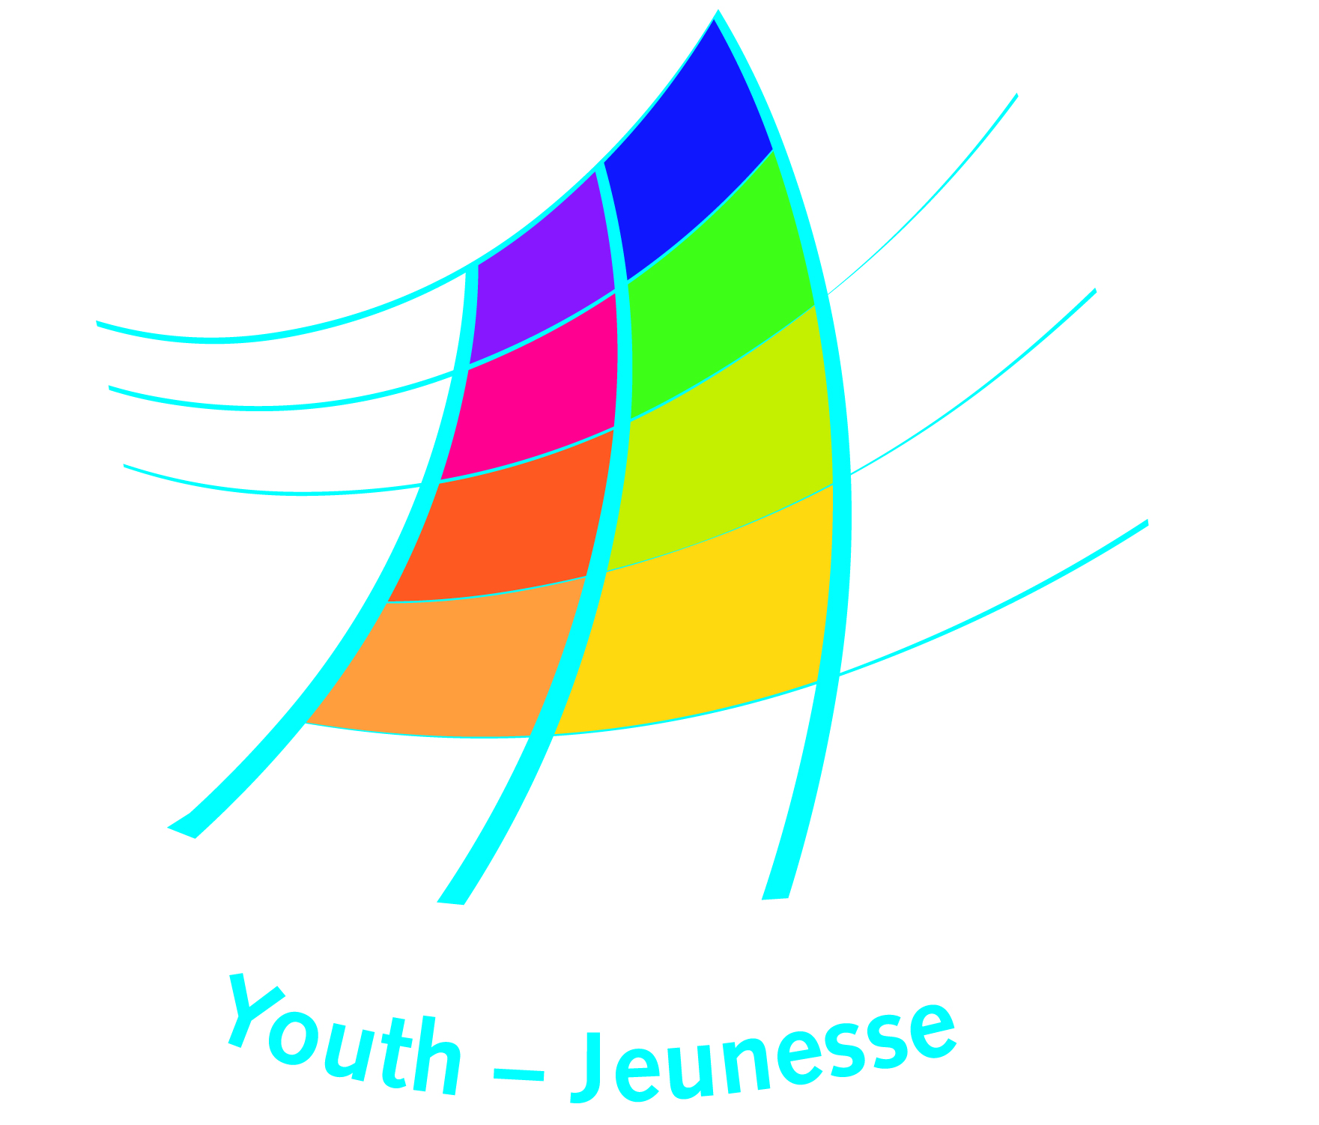

DDCP-YD/ETD (2016) 214 Strasbourg, 30 November 2016

Call for Expressions of Interest

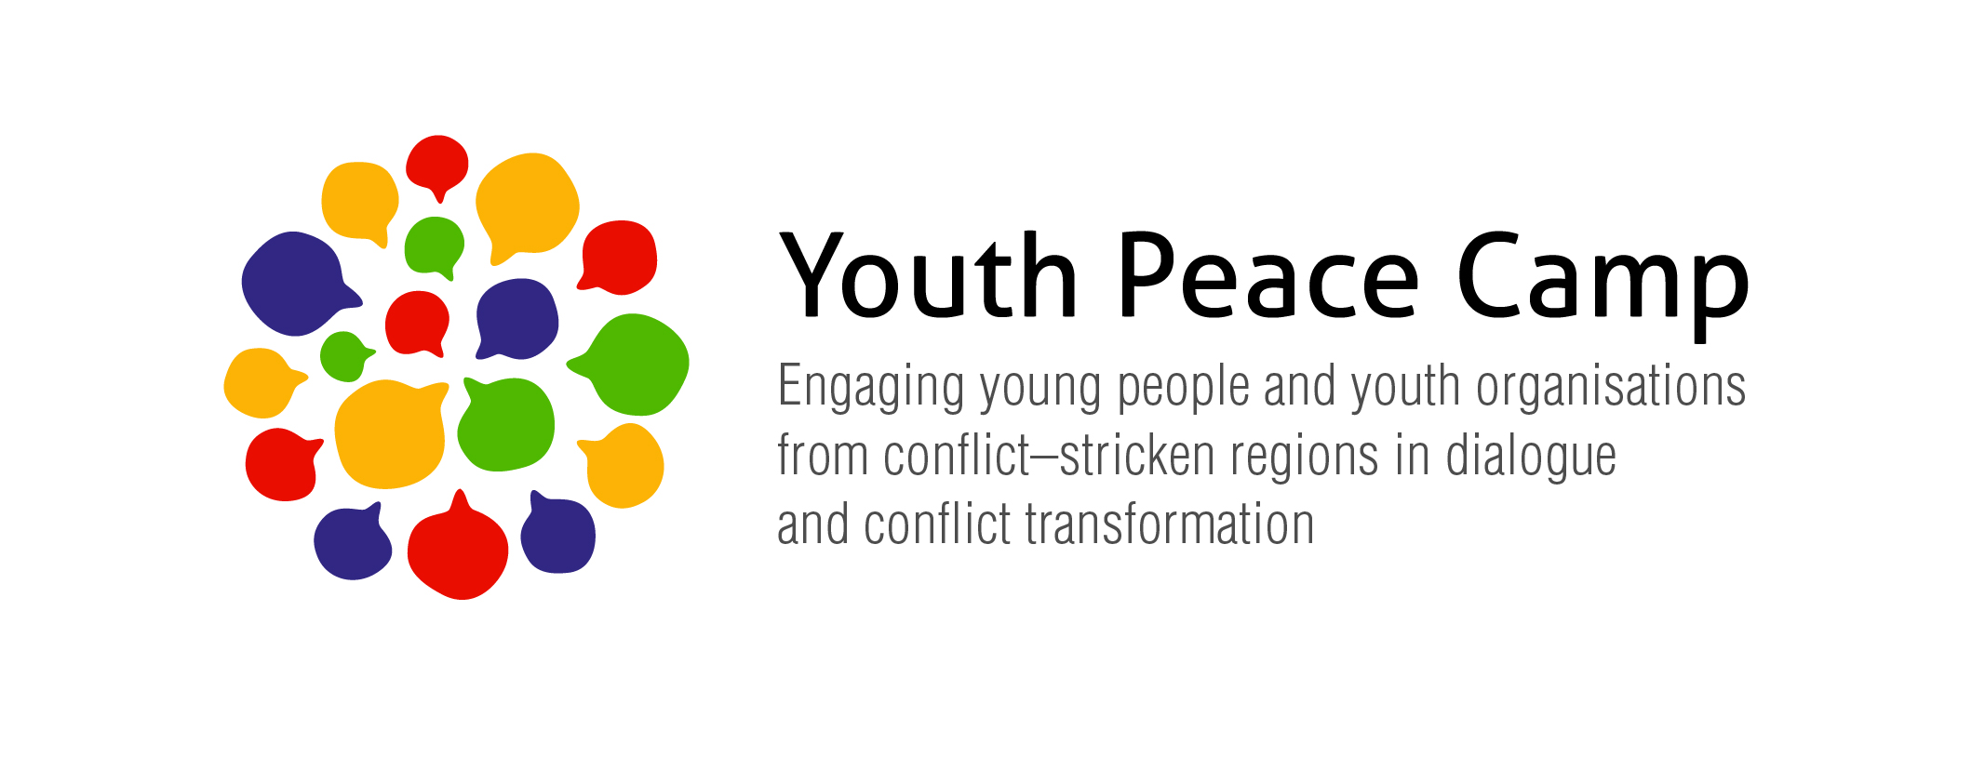
10 facilitators (junior trainers)

9 working days in the period 28 April – 8 May 2016

Dates of the preparatory meeting:
16-18 January 2017
European Youth Centre Strasbourg

Language of the course: English
(please see other language requirements below)

Introduction:

The Youth Department of the Council of Europe is looking for 10 facilitators to support the preparation and implementation of the programme of the Youth Peace Camp 2017. The facilitators should potentially have the profile of junior trainers of the Trainers Pool of the Youth Department. The facilitators will work together with the trainer/s of the camp and be involved in the selection of participants and development of the programme of the week during the preparation meeting. They’ll will also assist the preparation of the participants, support them during the Youth Peace Camp and, when possible, support also their follow-up to the camp. The facilitators are also expected to facilitate the groups of participants from the same region/community as well as specific working groups or workshops during the programme of the camp at the European Youth Centre in Strasbourg.

In 2017, the camp will bring together groups of young people (aged 18-25) from the following countries and communities: Cyprus (including North Cyprus), Kosovo*, the Russian Federation, Serbia, South Caucasus region and Ukraine during a nine day camp. Each group should include an average of 6 participants.

Aims and objectives

The Youth Peace Camp engages young people and youth organisations from conflict affected regions in dialogue and conflict transformation activities based on human rights education and intercultural learning during and after the camp.

The objectives (personal, organisational and institutional) of the Youth Peace Camp are:

- To develop awareness and basic competences (knowledge, skills and attitude) of participants in human rights education, conflict transformation, intercultural learning and dialogue so as to enable them to engage in dialogue and confidence-building initiatives with other young people affected by conflict
- To enable participants to share personal experiences of conflict and violence and coping strategies in a positive and safe atmosphere of living and learning together
- To introduce and share existing youth work practices and experiences of young people working on dialogue and conflict transformation in their home communities
- To motivate and support participants in their role as multipliers and peer leaders in peace building activities with young people encouraging them to implement follow-up initiatives
- To strengthen the role of the Council of Europe, in particular through its Youth for Democracy programme, in its efforts towards strengthening youth work in the field of conflict transformation, social cohesion and intercultural dialogue.

Required competencies of the Facilitators

Each group of participants will be accompanied by a facilitator. The facilitators’ primary role is to act as a contact person for the young participants from the respective regions before the Youth Peace Camp, facilitate their learning process and experiences during the Youth Peace Camp and follow up with them afterwards. Additionally, the facilitators are expected to take part in the evaluation and documentation process of the programme and to contribute to the programme of the Youth Peace Camp in ways which will be decided on during the preparatory meeting.

During the Youth Peace Camp the role of the facilitators will be comparable to being a youth leader, meaning to support the participants from their respective regions and ensure their well being and facilitate their personal process of learning and reflection. The Youth Peace Camp will include working group sessions mixing participants from the different regions and conflicts as also between participants within the regional groups. The facilitators must be able and feel comfortable to facilitate such group activities, and be able to work in a participant’s group native language and in English.

*All reference to Kosovo, whether to the territory, institutions or population, in this text shall be understood in full compliance with the United Nations Security Council Resolutions 1244 and without prejudice to the status of Kosovo
The facilitators will participate in:
- the preparation meetings
- the selection of the participants and be a contact person for the participants in preparation for the Youth Peace Camp
- the preparation of the Youth Peace Camp detailed daily programme, methodology and working methods
- running or facilitating or co-facilitating working groups and workshops, where relevant,
- running the informal parts of the programme
- the evaluation and follow-up process

The facilitators should have the following competences:
- Be motivated and willing to engage with an open mind into positive, constructive and respectful dialogue with other people taking part in the project; additionally, have the intention to promote and facilitate such an attitude among all the participants in the project
- have the motivation and capacity to support participants in their role as multipliers and peer educators in peace activities with young people from their organisations and communities
- speak the native language(s) of the region of the group they will facilitate (this is a hard criteria)
- have previous experience with intercultural youth work or/and peace-building and conflict transformation
- be acquainted with the principles and, desirably, the practice of human rights education.

The Youth Department of the Council of Europe will contract up to 10 facilitators (junior trainer contracts) for this project able to communicate and work with the following groups of participants:
- Abkhaz
- Armenians
- Azerbaijanis
- Greek Cypriots
- Georgians
- Kosovans (Albanian speakers)
- South Ossetians
- Russians
- Serbians and other communities from Kosovo
- Turkish Cypriots
- Ukrainians

The facilitators must be fully available for the preparatory meeting in January and the Youth Peace Camp in April/May.

Procedure and inquiry
Applicants interested in this call must express their interest by filling in the appended form and return it to dys.trainers.pool@coe.int. For further question, you can also send an email to dys.trainers.pool@coe.int to the attention of Laszlo Milutinovits, educational advisor.

Deadline for expressing of interest for this programme: Monday 12 December 2016.

Directorate of Democratic Citizenship and Participation
Youth Department

Form for expression of interest

Call | Ten Facilitators  Youth Peace Camp 2017  9 working days in the period of  28 April-9 May 2016, Strasbourg  Final prep meeting 25-27 April  Preparatory meeting: 16-18 January 2016, Strasbourg  Deadline: 12th December 2016
Name and SURNAME: | Mr Ms
Email:
Telephone/s:
Address:
Youth group you wish to facilitate  (select only one) | Armenian Azerbaijani Georgian  Abkhazian or South Ossetian  Kosovan, Albanian speaking community  Kosovan, Serbian speaking community  Serbian Ukrainian  Russian or Russian speaking community in (fill in)  Cypriot, Greek speaking community  Cypriot, Turkish speaking community
Working languages: | English French Albanian Armenian  Azerbaijani Georgian Russian Serbian  Ukrainian Greek Turkish Abkhaz  Ossetian  Other/s (please specify) ,

Please provide details about your experience and expertise about:

Dialogue work with young people

Intercultural youth work specially in settings of conflict struck communities

Conflict transformation/ peace work, for example explaining concepts related to positive & negative conflict, violence and non-violence

Support participants in their role as multipliers and peer educators in peace activities with young people from their organisations and communities

Please comment on how you can contribute to the following:
Have the willingness to engage with an open mind into positive, constructive and respectful dialogue with other people taking part in the project and have the intention to promote and facilitate such an attitude among all the participants in the project. (If possible share previous experiences in this regard.)

Your motivation to be a facilitator in this activity

Any additional information that might be relevant in assessing your application?

Deadline: Thursday 12th December 2016
Form to be returned to: dys.trainers.pool@coe.int

